Email to announce partnership of practice with Vets Choice
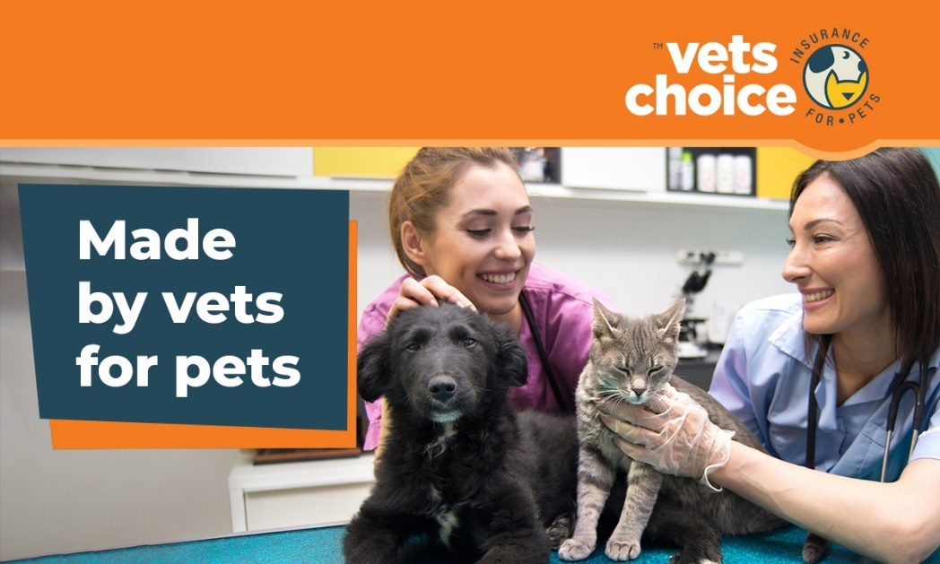
Dear (Valued Customer),
Today, we’d like to discuss pet insurance, and why we believe it’s helpful for pet owners.
When pets require emergency care, pet insurance can help by taking the pressure off the financial side of treatment. Especially when treatment plans require costly procedures with x-rays, overnight stays and surgery.
However, only 7% of Australian pets are insured. Which sometimes makes it difficult for us vets to provide the care pets deserve.
We’ve chosen to partner with Vets Choice insurance for pets, the only pet insurer endorsed by the AVA, and now offer our customers more information about their pet insurance policies in our practice.
Vets Choice offers cover for pre-existing conditions as well as lifetime cover for pets while insured with them. Their policies also have flexible options to choose from, such as excess, benefit level and add-ons like dental cover - all to help you build a policy that works for you and your pet
You can learn more about Vets Choice insurance for pets, or get a quote, right now by clicking below.
link: https://vetschoice.guildinsurance.com.au/
For any questions, you can speak directly with Vets Choice insurance for pets by calling 1800 999 738.
Kind regards,
(Your practice name here)

DISCLAIMER
Insurance issued by Guild Insurance Ltd. ABN 55 004 538 863. AFSL 233791 and subject to terms and conditions and exclusions. This information is of a general in nature only. Please refer to the Policy Disclosure Statement (PDS) and Target Market Determination (TMD) available at vetschoice.net.au/docs to see if this product is right for you. For more information contact Guild Insurance on 1800 999 738.

