Appoint follow up for patients with new pets eligible for Pro/Elite cover
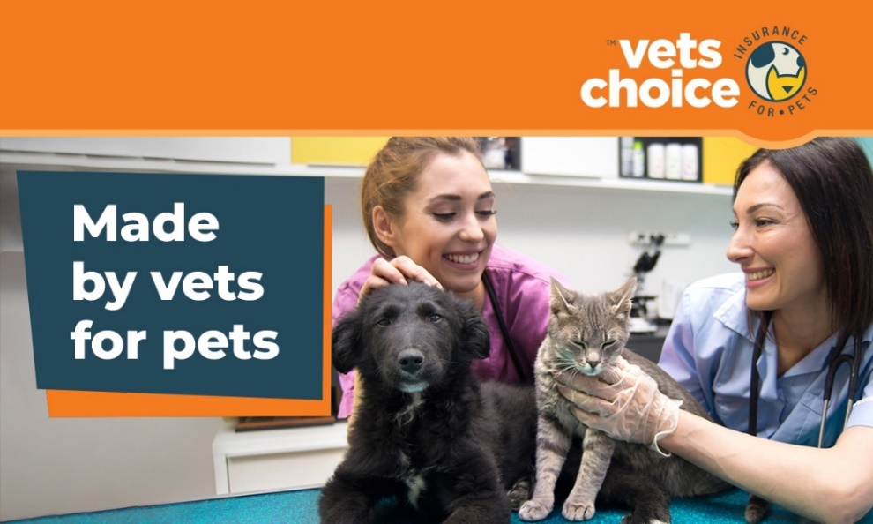

Dear (Valued Customer),
It was great seeing you today, and again we just want to say congratulations on your new family member, (insert pets name).
We just want to let you know a few things about pet insurance that could make a difference to your decision to insure your pet.
Only 7% of Australian pets are insured, which sometimes makes it difficult for us vets to provide the care pets deserve, especially in emergencies. And with insurers often refusing to insurer older pets, we’d encourage you to consider insuring your pet sooner rather than later.
This is because most insurers won't cover pets over eight years old or with pre-existing conditions. As pets age differently, problems associated with age can show up earlier than anticipated, so now more than ever is the best time to insure your pet.
It’s important to find an insurer that addresses your pets needs. We partner with Vets Choice insurance for pets, as they’re the only insurer endorsed by the Australian Veterinary Association (AVA), and offer cover for pre-existing conditions as well as life-time cover for pets while insured with them.
To find out more about Vets Choice insurance for pets, and to make sure it’s right for you and your new pet, click below.
link: https://vetschoice.guildinsurance.com.au/
Or, for any questions, you can speak directly with Vets Choice insurance for pets by calling 1800 999 738.
Kind regards,
(Your practice name here)

DISCLAIMER
Insurance issued by Guild Insurance Ltd. ABN 55 004 538 863. AFSL 233791 and subject to terms and conditions and exclusions. This information is of a general in nature only. Please refer to the Policy Disclosure Statement (PDS) and Target Market Determination (TMD) available at vetschoice.net.au/docs to see if this product is right for you. For more information contact Guild Insurance on 1800 999 738.

