Appoint follow up for patients with new pets eligible for Rookie (new puppies & kittens)
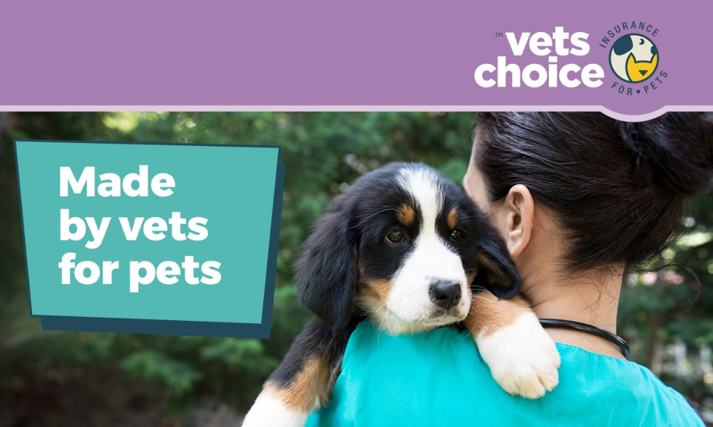

Dear (Valued Customer),
It was great seeing you today, and again we just want to say congratulations on your new family member, (insert pets name).
(Insert pet name) is now at an age where they’re going to explore everything. He/she might chew on things they shouldn’t, poke their head in a few gardens that you don’t want them to, and do mad runs at any moment.
If anything happens that concerns you, we’re here to help. We’ve also attached an eBook from our partners Vets Choice insurance for pets, which includes lots of helpful information about your pet in their first six months.
There’s also some information about the Vets Choice Rookie policy at the end of this eBook, which is a free 28-day insurance policy available to pets under six months old.
Now is the best time to insure your pet, as many insurers won’t cover pre-existing conditions. As the Vets Choice Rookie is a free policy with no obligation to continue after, we would love to help set this up for you and (insert pets name) at your next appointment.
If you haven’t organised your next check-up, give us a call on (insert your phone number) or email us on (insert your email address).
Kind regards,
(Your practice name here)

DISCLAIMER
Insurance issued by Guild Insurance Ltd. ABN 55 004 538 863. AFSL 233791 and subject to terms and conditions and exclusions. This information is of a general in nature only. Please refer to the Policy Disclosure Statement (PDS) and Target Market Determination (TMD) available at vetschoice.net.au/docs to see if this product is right for you. For more information contact Guild Insurance on 1800 999 738.

