## Email to promote pet insurance to pet owners

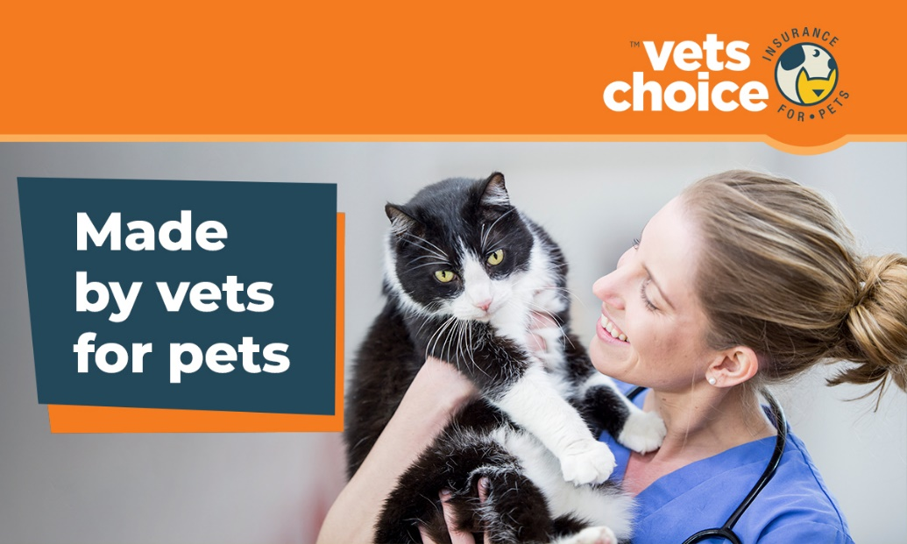

Hi (client name),

Nothing matters more to us than the health and safety of your pet. Your pet is more than just a companion, they’re a furry member of the family. They brighten your life, make you laugh and are always happy to see you.

However, unlike people, pets don’t always act the way they should. They get silly, eat things they shouldn’t and aren’t always predictable. And while you can’t predict if your pet is going to get injured or sick, you can prepare for it.

Pet insurance is a great option for pets and is often compared to private health insurance for people. Unfortunately, there is no Medicare equivalent for pets and in the case your pet gets sick, you could be facing a large unexpected vet bill, potentially costing thousands of dollars.

Pet insurance could remove the need for you to have to make a difficult decision. We encourage you to look for the best option for your pet, as the right pet insurance policy can help with unexpected bills.

We partner with Vets Choice insurance for pets, as they’re the only insurer endorsed by the Australian Veterinary Association (AVA), and offer cover for pre-existing conditions as well as lifetime cover for pets while insured with them. Their policies also have flexible options to choose from, such as excess, benefit level and add-ons like dental cover - all to help you build a policy that works for you and your pet.

To find out more about Vets Choice and how they can protect your pet, click below.

[](go.guildinsurance.com.au/Vets-Choice.html) link: <https://vetschoice.guildinsurance.com.au/>

For more information, visit **vetschoice.net.au** or call **1800 999 738**.

Kind regards,

(Your practice name here)

## DISCLAIMER

*Insurance issued by Guild Insurance Ltd. ABN 55 004 538 863. AFSL 233791 and subject to terms and conditions and exclusions. This information is of a general in nature only. Please refer to the Policy Disclosure Statement (PDS) and Target Market Determination (TMD) available at vetschoice.net.au/docs to see if this product is right for you. For more information contact Guild Insurance on 1800 999 738.*